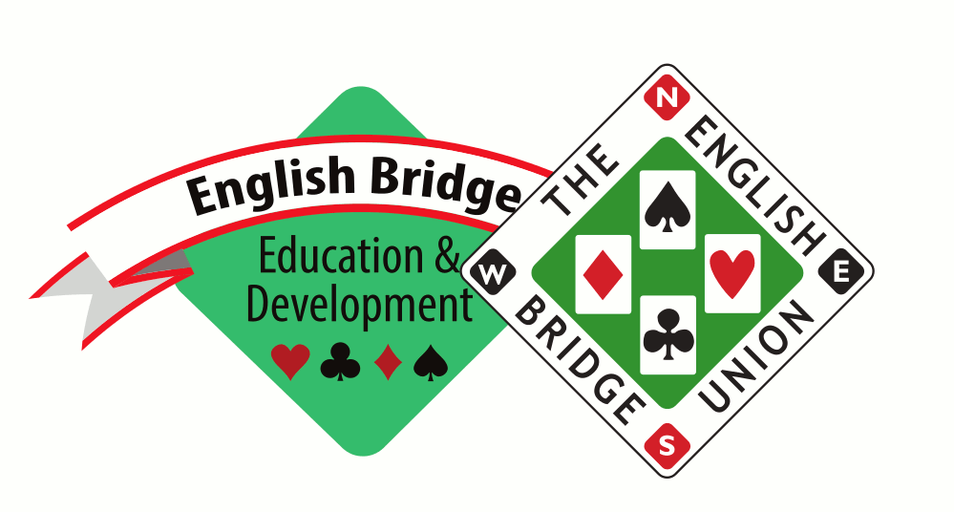

NOMINATION FORM FOR ALEC SALISBURY AWARD 2021

The Alec Salisbury Award is given in recognition of a schoolteacher who has made a significant contribution to Youth Bridge.

Typical achievements might include: the establishment of a school bridge club, or developing the range of the players within that club; participation in County/EBED youth events; support for Junior Award Scheme; promotion of academic and non- academic benefits of bridge within the school and community.

Please provide name and details of nominee achievements using some or all of the criteria above.

Full Name:

Declaration

I confirm to the best of my knowledge that the information that I have provided in this nomination form is accurate and true.

Nominated by:

Signature:

Date:

Your nomination will be reviewed by EBED and the EBU Awards Sub Committee, who will be in contact in due course within the parameters of the nomination process.

CLOSING DATE FOR NOMINATIONS IS 29th July 2021

Please send completed forms to Stephen Hull, Bridge for Youth Officer, stephen@ebedcio.org.uk

